Download and install the current latest version for Windows, as the Webstorm JavaScript project requires a copy of the .venv folder.
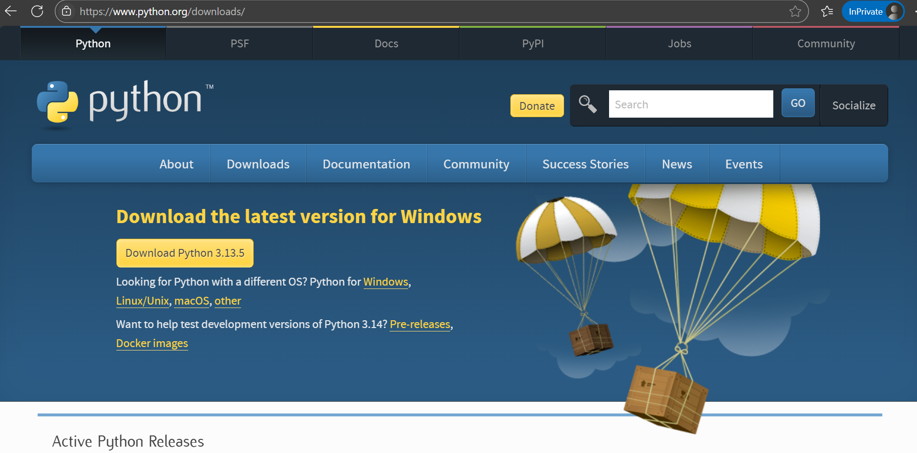

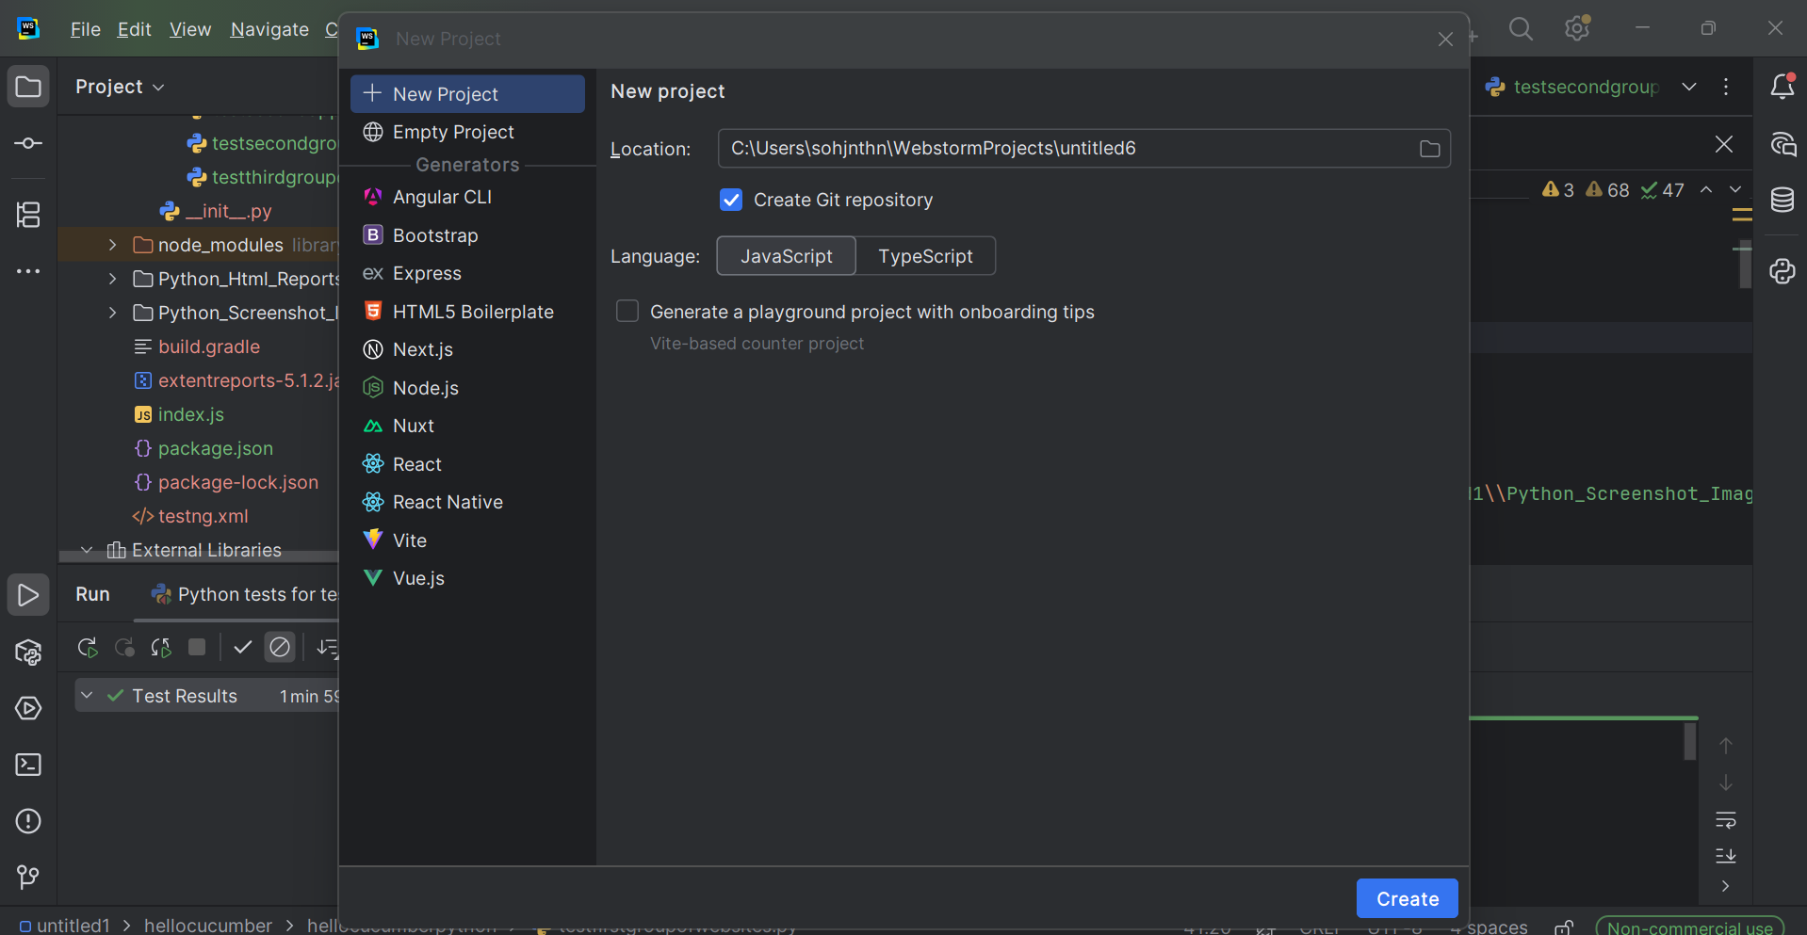

We refer to this .venv folder which states “library root”, at the top left of this screenshot image.
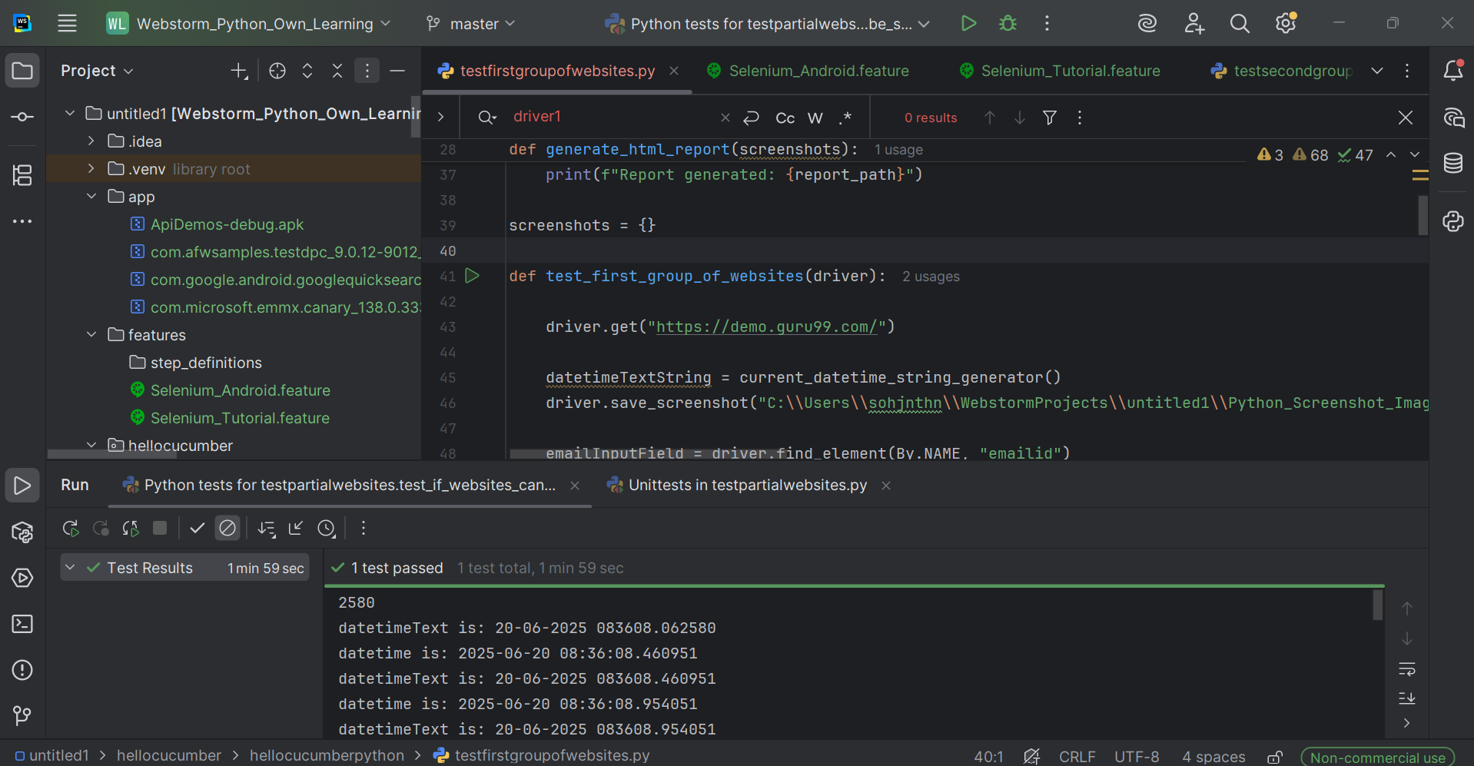

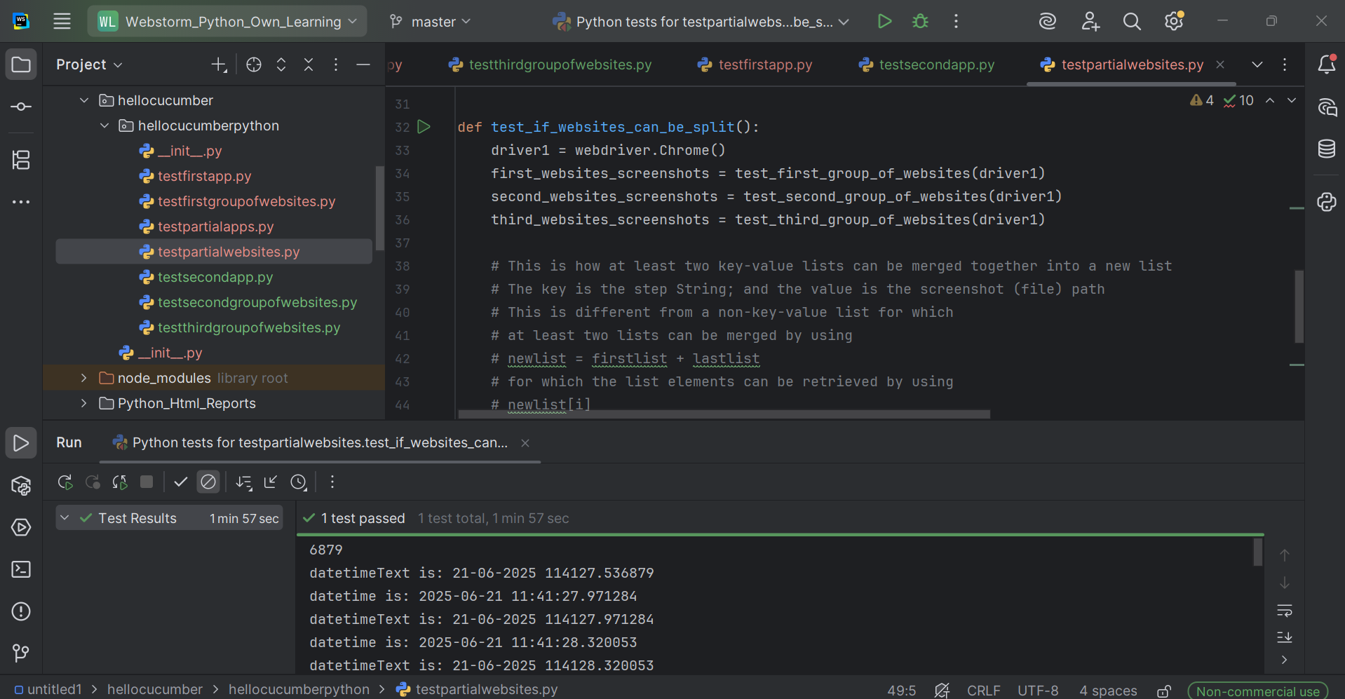

Click on the run button (the green right-pointing triangle for the following screenshot image, which is beside the code line

def test_if_websites_can_be_split():

) to run tests for the functions, for which the function names should start with “test_”, otherwise, other existing Python files for the same project would also run first unexpectedly. Do not use any test configuration.

Now able to generate the separate html reports for testing websites; and for testing the two smartphone applications.
testpartialwebsites.py
(Please kindly note that the function to call the main smartphone application Python file testpartialapps.py is included.)

from selenium import webdriver

from datetime import datetime

from hellocucumber.hellocucumberpython.testpartialapps import test_if_websites_can_call_apps

from hellocucumber.hellocucumberpython.testfirstgroupofwebsites import test_first_group_of_websites
from hellocucumber.hellocucumberpython.testsecondgroupofwebsites import test_second_group_of_websites
from hellocucumber.hellocucumberpython.testthirdgroupofwebsites import test_third_group_of_websites

def current_datetime_string_generator():
datetimee = datetime.now()
print("datetime is: " + datetimee.__str__())
datetimeeText = datetimee.strftime("%d-%m-%Y %H%M%S.%f")
datetimeeTextString = datetimeeText.__str__()
print("datetimeText is: " + datetimeeTextString)
return datetimeeTextString

def generate_html_report(screenshots):
report_path = "C:\\Users\\sohjnthn\\WebstormProjects\\untitled1\\Python_Html_Reports\\" + current_datetime_string_generator() + "_test_report.html"
with open(report_path, "w") as report:
report.write("<html><head><title>Test Report</title></head><body>")
report.write("<h1>Test Report with Screenshots</h1>")
for step, screenshot in screenshots.items():
report.write(f"<h2>{step}</h2>")
report.write(f'<img src="{screenshot}" alt="{step}" style="height:410px;width:820px;"><br>')
report.write("</body></html>")
print(f"Report generated: {report_path}")

screenshots = {}

def test_if_websites_can_be_split():
driver1 = webdriver.Chrome()
first_websites_screenshots = test_first_group_of_websites(driver1)
second_websites_screenshots = test_second_group_of_websites(driver1)
third_websites_screenshots = test_third_group_of_websites(driver1)

# This is how at least two key-value lists can be merged together into a new list
# The key is the step String; and the value is the screenshot (file) path
# This is different from a non-key-value list for which
# at least two lists can be merged by using
# newlist = firstlist + lastlist
# for which the list elements can be retrieved by using
# newlist[i]
# for which i is an int number
# like how a list of WebElements's specific element for the int position (which starts from 0)
# is retrieved
screenshots = {**first_websites_screenshots, **second_websites_screenshots, **third_websites_screenshots}
generate_html_report(screenshots)

# Only for executing testpartialapps.py
#test_if_websites_can_call_apps()

testfirstgroupofwebsites.py

from selenium.webdriver.common.by import By

from datetime import datetime

from selenium.webdriver.common.utils import Keys

import os

def current_datetime_string_generator():
datetimee = datetime.now()
print("datetime is: " + datetimee.__str__())
datetimeeText = datetimee.strftime("%d-%m-%Y %H%M%S.%f")
datetimeeTextString = datetimeeText.__str__()
print("datetimeText is: " + datetimeeTextString)
return datetimeeTextString

def take_screenshot(driver, step_name):
datetimeeeText = datetime.now().strftime("%d-%m-%Y %H%M%S.%f")
datetimeeeTextString = datetimeeeText.__str__()
screenshot_path = os.path.join("C:\\Users\\sohjnthn\\WebstormProjects\\untitled1\\Python_Screenshot_Images\\" + datetimeeeTextString + "_screenshot.png")
driver.save_screenshot(screenshot_path)
return screenshot_path

screenshots = {}

def test_first_group_of_websites(driver):

driver.get("https://demo.guru99.com/")

datetimeTextString = current_datetime_string_generator()
driver.save_screenshot("C:\\Users\\sohjnthn\\WebstormProjects\\untitled1\\Python_Screenshot_Images\\" + datetimeTextString + "_" + "screenshot.png")

emailInputField = driver.find_element(By.NAME, "emailid")

datetimeTextString = current_datetime_string_generator()
driver.save_screenshot("C:\\Users\\sohjnthn\\WebstormProjects\\untitled1\\Python_Screenshot_Images\\" + datetimeTextString + "_" + "screenshot.png")
if emailInputField.is_displayed():
screenshots["The Email Input Field is displayed; Pass."] = take_screenshot(driver, "The Email Input Field is displayed; Pass.")
else:
screenshots["The Email Input Field is not displayed; Fail."] = take_screenshot(driver, "The Email Input Field is not displayed; Fail.")

emailInputField.send_keys("abc@gmail.com")

datetimeTextString = current_datetime_string_generator()
driver.save_screenshot("C:\\Users\\sohjnthn\\WebstormProjects\\untitled1\\Python_Screenshot_Images\\" + datetimeTextString + "_" + "screenshot.png")
if emailInputField.is_displayed():
screenshots["The Email Input Field's text \"abc@gmail.com\" is displayed; Pass."] = take_screenshot(driver, "The Email Input Field's text \"abc@gmail.com\" is displayed; Pass.")
else:
screenshots["The Email Input Field's text \"abc@gmail.com\" is not displayed; Fail."] = take_screenshot(driver, "The Email Input Field's text \"abc@gmail.com\" is not displayed; Fail.")

submitButton = driver.find_element(By.NAME, "btnLogin")

datetimeTextString = current_datetime_string_generator()
driver.save_screenshot("C:\\Users\\sohjnthn\\WebstormProjects\\untitled1\\Python_Screenshot_Images\\" + datetimeTextString + "_" + "screenshot.png")
if submitButton.is_displayed():
screenshots["The Submit Button is displayed; Pass."] = take_screenshot(driver, "The Submit Button is displayed; Pass.")
else:
screenshots["The Submit Button is not displayed; Fail."] = take_screenshot(driver, "The Submit Button is not displayed; Fail.")

submitButton.click()

datetimeTextString = current_datetime_string_generator()
driver.save_screenshot("C:\\Users\\sohjnthn\\WebstormProjects\\untitled1\\Python_Screenshot_Images\\" + datetimeTextString + "_" + "screenshot.png")
screenshots["The resulting webpage has been reached; Pass."] = take_screenshot(driver, "The resulting webpage has been reached; Pass.")

driver.get("https://www.bing.com")

datetimeTextString = current_datetime_string_generator()
driver.save_screenshot("C:\\Users\\sohjnthn\\WebstormProjects\\untitled1\\Python_Screenshot_Images\\" + datetimeTextString + "_" + "screenshot.png")
if driver.title.__eq__("Search - Microsoft Bing"):
screenshots["The Microsoft Bing webpage has been reached; Pass."] = take_screenshot(driver, "The Microsoft Bing webpage has been reached; Pass.")
else:
screenshots["The Microsoft Bing webpage has not been reached; Fail."] = take_screenshot(driver, "The Microsoft Bing webpage has been reached; Fail.")

microsoftBingSearchBar = driver.find_element(By.NAME, "q")

datetimeTextString = current_datetime_string_generator()
driver.save_screenshot("C:\\Users\\sohjnthn\\WebstormProjects\\untitled1\\Python_Screenshot_Images\\" + datetimeTextString + "_" + "screenshot.png")

if microsoftBingSearchBar.is_displayed():
screenshots["The Microsoft Bing search bar is displayed; Pass."] = take_screenshot(driver, "The Microsoft Bing search bar is displayed; Pass.")
else:
screenshots["The Microsoft Bing search bar is not displayed; Fail."] = take_screenshot(driver, "The Microsoft Bing search bar is not displayed; Fail.")

microsoftBingSearchBar.send_keys("MapleStorySEA (South-East Asia) tips [Facebook notes]")

datetimeTextString = current_datetime_string_generator()
driver.save_screenshot("C:\\Users\\sohjnthn\\WebstormProjects\\untitled1\\Python_Screenshot_Images\\" + datetimeTextString + "_" + "screenshot.png")
screenshots["The Microsoft Bing search bar's search term \"MapleStorySEA (South-East Asia) tips [Facebook notes]\" has been entered; Pass."] = take_screenshot(driver, "The Microsoft Bing search bar's search term \"MapleStorySEA (South-East Asia) tips [Facebook notes]\" has been entered; Pass.")

microsoftBingSearchBarMagnifyingGlassButton = driver.find_element(By.ID, "search_icon")

if microsoftBingSearchBarMagnifyingGlassButton.is_displayed():
screenshots["The Microsoft Bing search bar's magnifying glass button is displayed; Pass."] = take_screenshot(driver, "The Microsoft Bing search bar's magnifying glass button is displayed; Pass.")
else:
screenshots["The Microsoft Bing search bar's magnifying glass button is not displayed; Fail."] = take_screenshot(driver, "The Microsoft Bing search bar's magnifying glass button is not displayed; Fail.")

datetimeTextString = current_datetime_string_generator()
driver.save_screenshot("C:\\Users\\sohjnthn\\WebstormProjects\\untitled1\\Python_Screenshot_Images\\" + datetimeTextString + "_" + "screenshot.png")

microsoftBingSearchBarMagnifyingGlassButton.click()

for i in range(99999):
print("Wait for the initial \"MapleStorySEA (South-East Asia) tips [Facebook notes] - Search\" webpage to finish loading.")

datetimeTextString = current_datetime_string_generator()
driver.save_screenshot("C:\\Users\\sohjnthn\\WebstormProjects\\untitled1\\Python_Screenshot_Images\\" + datetimeTextString + "_" + "screenshot.png")
screenshots["The Search Results webpage has been reached; Pass."] = take_screenshot(driver, "The Search Results webpage has been reached; Pass.")

datetimeTextString = current_datetime_string_generator()
driver.save_screenshot("C:\\Users\\sohjnthn\\WebstormProjects\\untitled1\\Python_Screenshot_Images\\" + datetimeTextString + "_" + "screenshot.png")

#searchTab = driver.find_element(By.ID, "b-scopeListItem-copilotsearch")

#if searchTab.is_displayed():
#screenshots["The Search tab is displayed; Pass."] = take_screenshot(driver, "The Search tab is displayed; Pass.")
#else:
#screenshots["The Search tab is not displayed; Fail."] = take_screenshot(driver, "The Search tab is not displayed; Fail.")

#datetimeTextString = current_datetime_string_generator()
#driver.save_screenshot("C:\\Users\\sohjnthn\\WebstormProjects\\untitled1\\Python_Screenshot_Images\\" + datetimeTextString + "_" + "screenshot.png")

#searchTab.click()

#datetimeTextString = current_datetime_string_generator()
#driver.save_screenshot("C:\\Users\\sohjnthn\\WebstormProjects\\untitled1\\Python_Screenshot_Images\\" + datetimeTextString + "_" + "screenshot.png")

#allTab = driver.find_element(By.ID, "b-scopeListItem-web")

#datetimeTextString = current_datetime_string_generator()
#driver.save_screenshot("C:\\Users\\sohjnthn\\WebstormProjects\\untitled1\\Python_Screenshot_Images\\" + datetimeTextString + "_" + "screenshot.png")

#if allTab.is_displayed():
#screenshots["The All tab is displayed; Pass."] = take_screenshot(driver, "The All tab is displayed; Pass.")
#else:
#screenshots["The All tab is not displayed; Fail."] = take_screenshot(driver, "The All tab is not displayed; Fail.")

#allTab.click()

driver.get("https://maplestoryseatips.blogspot.com/")

datetimeTextString = current_datetime_string_generator()
driver.save_screenshot("C:\\Users\\sohjnthn\\WebstormProjects\\untitled1\\Python_Screenshot_Images\\" + datetimeTextString + "_" + "screenshot.png")
if datetimeTextString.__eq__(datetimeTextString):
screenshots["The Search Results webpage is reached; Pass."] = take_screenshot(driver, "The Search Results webpage is reached; Pass.")
else:
screenshots["The Search Results webpage is not reached; Fail."] = take_screenshot(driver, "The Search Results webpage is not reached; Fail.")

displayedText = driver.find_element(By.PARTIAL_LINK_TEXT, "[MapleStorySEA] Typed some extra things here")

if displayedText.is_displayed():
print("https://maplestoryseatips.blogspot.com/ is reached")
screenshots["The default Blogger webpage is reached; Pass."] = take_screenshot(driver, "The default Blogger webpage is reached; Pass.")
else:
print("https://maplestoryseatips.blogspot.com/ is not reached.")
screenshots["The default Blogger webpage is not reached; Fail."] = take_screenshot(driver, "The default Blogger webpage is not reached; Fail.")

toggleList1 = driver.find_elements(By.CLASS_NAME, "post-count-link")
zippyToggleOpenForTheYear2026 = toggleList1[45]

for i in range(5):
zippyToggleOpenForTheYear2026.send_keys(Keys.DOWN)
datetimeTextString = current_datetime_string_generator()
driver.save_screenshot("C:\\Users\\sohjnthn\\WebstormProjects\\untitled1\\Python_Screenshot_Images\\" + datetimeTextString + "_" + "screenshot.png")

if zippyToggleOpenForTheYear2026.is_displayed():
print("zippyToggleOpenForTheYear2026 is displayed (the className post-count-link of the text 2026 is used for finding the text at the right of the arrow).")
screenshots["zippyToggleOpenForTheYear2026 is displayed (the className post-count-link of the text 2026 is used for finding the text at the right of the arrow); Pass."] = take_screenshot(driver, "zippyToggleOpenForTheYear2026 is displayed (the className post-count-link of the text 2026 is used for finding the text at the right of the arrow); Pass.")
else:
print("zippyToggleOpenForTheYear2026 is not displayed (the className post-count-link of the text 2026 is used for finding the text at the right of the arrow).")
screenshots["zippyToggleOpenForTheYear2026 is not displayed (the className post-count-link of the text 2026 is used for finding the text at the right of the arrow); Fail."] = take_screenshot(driver, "zippyToggleOpenForTheYear2026 is not displayed (the className post-count-link of the text 2026 is used for finding the text at the right of the arrow); Fail.")

tagAWebElementList = driver.find_elements(By.TAG_NAME, "a")
arrowForToggleOpenForTheYear2026 = tagAWebElementList[128]
arrowForToggleOpenForTheYear2026.click()

datetimeTextString = current_datetime_string_generator()
driver.save_screenshot("C:\\Users\\sohjnthn\\WebstormProjects\\untitled1\\Python_Screenshot_Images\\" + datetimeTextString + "_" + "screenshot.png")

theText2026 = driver.find_element(By.PARTIAL_LINK_TEXT, "2026")
theText2026.click()

displayedText2 = driver.find_element(By.PARTIAL_LINK_TEXT, "[MapleStorySEA] Create your own guild to boost all characters' damage ranges")

datetimeTextString = current_datetime_string_generator()
driver.save_screenshot("C:\\Users\\sohjnthn\\WebstormProjects\\untitled1\\Python_Screenshot_Images\\" + datetimeTextString + "_" + "screenshot.png")

if displayedText2.is_displayed():
print("The bottommost note for 2026 is displayed.")
screenshots["The bottommost note for 2026 is displayed; Pass."] = take_screenshot(driver, "The bottommost note for January 2026 (the first note for January 2026) is displayed at the bottom of the current webpage; Pass.")
else:
print("The bottommost note for 2026 is not displayed.")
screenshots["The bottommost note for 2026 is not displayed; Fail."] = take_screenshot(driver, "The bottommost note for January 2026 (the first note for January 2026) is not displayed at the bottom of the current webpage; Fail.")

for i in range (5):
displayedText2.send_keys(Keys.DOWN)
datetimeTextString = current_datetime_string_generator()
driver.save_screenshot("C:\\Users\\sohjnthn\\WebstormProjects\\untitled1\\Python_Screenshot_Images\\" + datetimeTextString + "_" + "screenshot.png")

if displayedText2.is_displayed:
print("The bottommost note for January 2026 is displayed; and is reached.")
screenshots["The bottommost note for January 2026 is displayed; and is reached; Pass."] = take_screenshot(driver, "The bottommost note for 2026 (the first note for January 2026) is displayed at the bottom of the current webpage; and is reached; Pass.")
else:
print("The bottommost note for January 2026 is displayed; and is not reached.")
screenshots["The bottommost note for January 2026 is not displayed; and is not reached; Fail."] = take_screenshot(driver, "The bottommost note for 2026 (the first note for January 2026) is not displayed at the bottom of the current webpage; and is not reached; Fail.")

datetimeTextString = current_datetime_string_generator()
driver.save_screenshot("C:\\Users\\sohjnthn\\WebstormProjects\\untitled1\\Python_Screenshot_Images\\" + datetimeTextString + "_" + "screenshot.png")

datetimeTextString = current_datetime_string_generator()
driver.save_screenshot("C:\\Users\\sohjnthn\\WebstormProjects\\untitled1\\Python_Screenshot_Images\\" + datetimeTextString + "_" + "screenshot.png")

datetimeTextString = current_datetime_string_generator()
driver.save_screenshot("C:\\Users\\sohjnthn\\WebstormProjects\\untitled1\\Python_Screenshot_Images\\" + datetimeTextString + "_" + "screenshot.png")

datetimeTextString = current_datetime_string_generator()
driver.save_screenshot("C:\\Users\\sohjnthn\\WebstormProjects\\untitled1\\Python_Screenshot_Images\\" + datetimeTextString + "_" + "screenshot.png")

datetimeTextString = current_datetime_string_generator()
driver.save_screenshot("C:\\Users\\sohjnthn\\WebstormProjects\\untitled1\\Python_Screenshot_Images\\" + datetimeTextString + "_" + "screenshot.png")

datetimeTextString = current_datetime_string_generator()
driver.save_screenshot("C:\\Users\\sohjnthn\\WebstormProjects\\untitled1\\Python_Screenshot_Images\\" + datetimeTextString + "_" + "screenshot.png")

datetimeTextString = current_datetime_string_generator()
driver.save_screenshot("C:\\Users\\sohjnthn\\WebstormProjects\\untitled1\\Python_Screenshot_Images\\" + datetimeTextString + "_" + "screenshot.png")

#threeWebElementsList = driver.find_elements(By.TAG_NAME, "svg")
datetimeTextString = current_datetime_string_generator()
driver.save_screenshot("C:\\Users\\sohjnthn\\WebstormProjects\\untitled1\\Python_Screenshot_Images\\" + datetimeTextString + "_" + "screenshot.png")

#tagNameH3WebElementList = driver.find_elements(By.TAG_NAME, "h3")
#popularPostsText = tagNameH3WebElementList[0]
#popularPostsTextString = popularPostsText.text
datetimeTextString = current_datetime_string_generator()
driver.save_screenshot("C:\\Users\\sohjnthn\\WebstormProjects\\untitled1\\Python_Screenshot_Images\\" + datetimeTextString + "_" + "screenshot.png")

datetimeTextString = current_datetime_string_generator()
driver.save_screenshot("C:\\Users\\sohjnthn\\WebstormProjects\\untitled1\\Python_Screenshot_Images\\" + datetimeTextString + "_" + "screenshot.png")

datetimeTextString = current_datetime_string_generator()
driver.save_screenshot("C:\\Users\\sohjnthn\\WebstormProjects\\untitled1\\Python_Screenshot_Images\\" + datetimeTextString + "_" + "screenshot.png")

datetimeTextString = current_datetime_string_generator()
driver.save_screenshot("C:\\Users\\sohjnthn\\WebstormProjects\\untitled1\\Python_Screenshot_Images\\" + datetimeTextString + "_" + "screenshot.png")

for i in range(55555):
print("Still loading.")

datetimeTextString = current_datetime_string_generator()
driver.save_screenshot("C:\\Users\\sohjnthn\\WebstormProjects\\untitled1\\Python_Screenshot_Images\\" + datetimeTextString + "_" + "screenshot.png")

for i in range(55555):
print("Still loading.")

datetimeTextString = current_datetime_string_generator()
driver.save_screenshot("C:\\Users\\sohjnthn\\WebstormProjects\\untitled1\\Python_Screenshot_Images\\" + datetimeTextString + "_" + "screenshot.png")

for i in range(55555):
print("Still loading.")

datetimeTextString = current_datetime_string_generator()
driver.save_screenshot("C:\\Users\\sohjnthn\\WebstormProjects\\untitled1\\Python_Screenshot_Images\\" + datetimeTextString + "_" + "screenshot.png")

for i in range(55555):
print("Still loading.")

datetimeTextString = current_datetime_string_generator()
driver.save_screenshot("C:\\Users\\sohjnthn\\WebstormProjects\\untitled1\\Python_Screenshot_Images\\" + datetimeTextString + "_" + "screenshot.png")

for i in range(55555):
print("Still loading.")
datetimeTextString = current_datetime_string_generator()
driver.save_screenshot("C:\\Users\\sohjnthn\\WebstormProjects\\untitled1\\Python_Screenshot_Images\\" + datetimeTextString + "_" + "screenshot.png")

for i in range(55555):
print("Still loading.")

datetimeTextString = current_datetime_string_generator()
driver.save_screenshot("C:\\Users\\sohjnthn\\WebstormProjects\\untitled1\\Python_Screenshot_Images\\" + datetimeTextString + "_" + "screenshot.png")

#sevenLabelClassnameWebElementList = driver.find_elements(By.CLASS_NAME, "label")
#requiredSecondLabelClassnameElement = sevenLabelClassnameWebElementList[1]

#requiredSecondLabelClassnameElement.click()

datetimeTextString = current_datetime_string_generator()
driver.save_screenshot("C:\\Users\\sohjnthn\\WebstormProjects\\untitled1\\Python_Screenshot_Images\\" + datetimeTextString + "_" + "screenshot.png")

return screenshots

testsecondgroupofwebsites.py

from datetime import datetime

import os

def current_datetime_string_generator():
datetimee = datetime.now()
print("datetime is: " + datetimee.__str__())
datetimeeText = datetimee.strftime("%d-%m-%Y %H%M%S.%f")
datetimeeTextString = datetimeeText.__str__()
print("datetimeText is: " + datetimeeTextString)
return datetimeeTextString

def take_screenshot(driver, step_name):
datetimeeeText = datetime.now().strftime("%d-%m-%Y %H%M%S.%f")
datetimeeeTextString = datetimeeeText.__str__()
screenshot_path = os.path.join("C:\\Users\\sohjnthn\\WebstormProjects\\untitled1\\Python_Screenshot_Images\\" + datetimeeeTextString + "_screenshot.png")
driver.save_screenshot(screenshot_path)
return screenshot_path

screenshots = {}

def test_second_group_of_websites(driver):

driver.get("https://maplestoryseatips.blogspot.com/")

datetimeTextString = current_datetime_string_generator()
driver.save_screenshot("C:\\Users\\sohjnthn\\WebstormProjects\\untitled1\\Python_Screenshot_Images\\" + datetimeTextString + "_" + "screenshot.png")
screenshots["The default Blogger webpage is reached; Pass"] = take_screenshot(driver, "The default Blogger webpage is reached; Pass.")

return screenshots

testthirdgroupofwebsites.py

from selenium.webdriver.common.by import By

from datetime import datetime

import os

def current_datetime_string_generator():
datetimee = datetime.now()
print("datetime is: " + datetimee.__str__())
datetimeeText = datetimee.strftime("%d-%m-%Y %H%M%S.%f")
datetimeeTextString = datetimeeText.__str__()
print("datetimeText is: " + datetimeeTextString)
return datetimeeTextString

def take_screenshot(driver, step_name):
datetimeeeText = datetime.now().strftime("%d-%m-%Y %H%M%S.%f")
datetimeeeTextString = datetimeeeText.__str__()
screenshot_path = os.path.join("C:\\Users\\sohjnthn\\WebstormProjects\\untitled1\\Python_Screenshot_Images\\" + datetimeeeTextString + "_screenshot.png")
driver.save_screenshot(screenshot_path)
return screenshot_path

screenshots = {}

def test_third_group_of_websites(driver):

driver.get("https://maplestoryseatips.blogspot.com/")
datetimeTextString = current_datetime_string_generator()
driver.save_screenshot("C:\\Users\\sohjnthn\\WebstormProjects\\untitled1\\Python_Screenshot_Images\\" + datetimeTextString + "_" + "screenshot.png")
screenshots["The default Blogger webpage is displayed; Pass."] = take_screenshot(driver, "The default Blogger webpage is displayed; Pass.")

datetimeTextString = current_datetime_string_generator()
driver.save_screenshot("C:\\Users\\sohjnthn\\WebstormProjects\\untitled1\\Python_Screenshot_Images\\" + datetimeTextString + "_" + "screenshot.png")

datetimeTextString = current_datetime_string_generator()
driver.save_screenshot("C:\\Users\\sohjnthn\\WebstormProjects\\untitled1\\Python_Screenshot_Images\\" + datetimeTextString + "_" + "screenshot.png")

datetimeTextString = current_datetime_string_generator()
driver.save_screenshot("C:\\Users\\sohjnthn\\WebstormProjects\\untitled1\\Python_Screenshot_Images\\" + datetimeTextString + "_" + "screenshot.png")

#tagNameButtonWebElementList = driver.find_elements(By.TAG_NAME, "button")
#createPostButton = tagNameButtonWebElementList[1]

datetimeTextString = current_datetime_string_generator()
driver.save_screenshot("C:\\Users\\sohjnthn\\WebstormProjects\\untitled1\\Python_Screenshot_Images\\" + datetimeTextString + "_" + "screenshot.png")

datetimeTextString = current_datetime_string_generator()
driver.save_screenshot("C:\\Users\\sohjnthn\\WebstormProjects\\untitled1\\Python_Screenshot_Images\\" + datetimeTextString + "_" + "screenshot.png")

datetimeTextString = current_datetime_string_generator()
driver.save_screenshot("C:\\Users\\sohjnthn\\WebstormProjects\\untitled1\\Python_Screenshot_Images\\" + datetimeTextString + "_" + "screenshot.png")

datetimeTextString = current_datetime_string_generator()
driver.save_screenshot("C:\\Users\\sohjnthn\\WebstormProjects\\untitled1\\Python_Screenshot_Images\\" + datetimeTextString + "_" + "screenshot.png")

datetimeTextString = current_datetime_string_generator()
driver.save_screenshot("C:\\Users\\sohjnthn\\WebstormProjects\\untitled1\\Python_Screenshot_Images\\" + datetimeTextString + "_" + "screenshot.png")

return screenshots

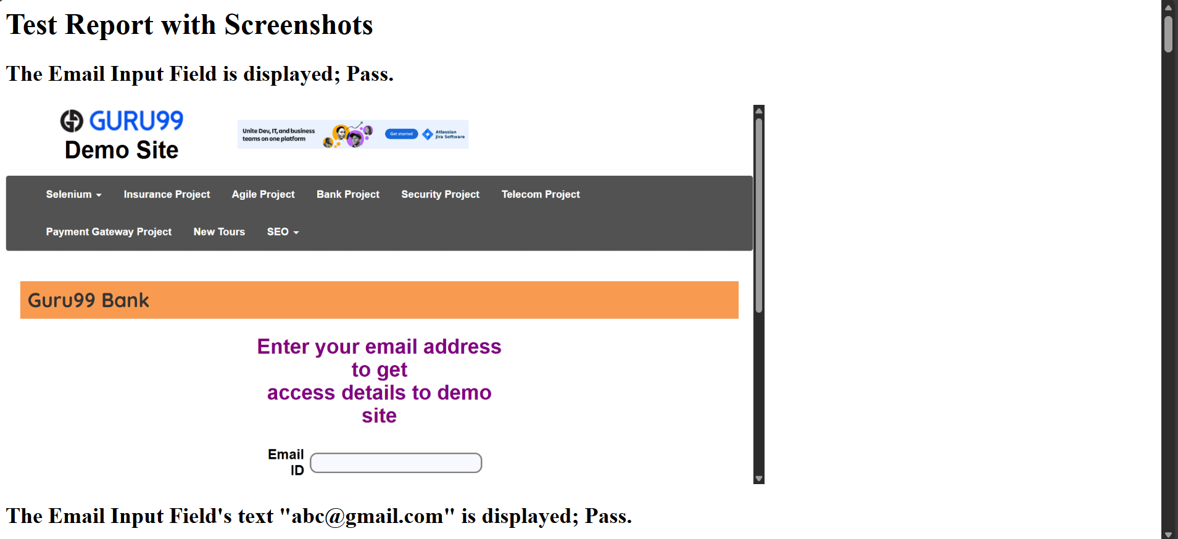

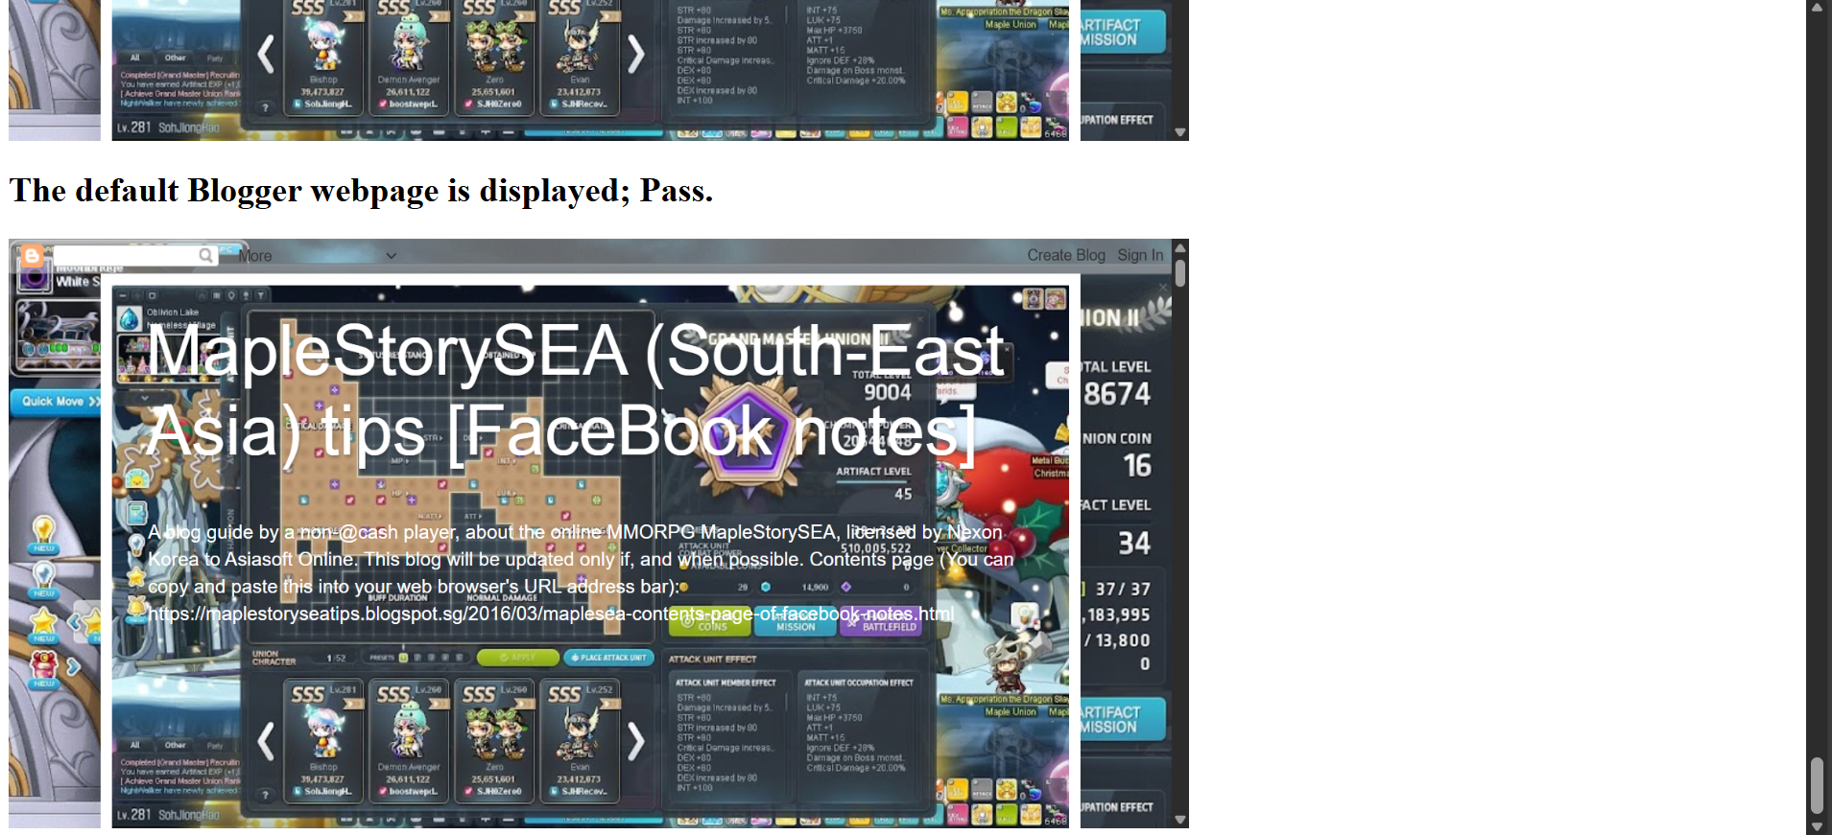

testpartialapps.py

from hellocucumber.hellocucumberpython.testfirstapp import test_first_app

from hellocucumber.hellocucumberpython.testsecondapp import test_second_app

from appium import webdriver
from appium.options.android import UiAutomator2Options

from datetime import datetime

def current_datetime_string_generator():
datetimee = datetime.now()
print("datetime is: " + datetimee.__str__())
datetimeeText = datetimee.strftime("%d-%m-%Y %H%M%S.%f")
datetimeeTextString = datetimeeText.__str__()
print("datetimeText is: " + datetimeeTextString)
return datetimeeTextString

def generate_html_report(screenshots):
report_path = "C:\\Users\\sohjnthn\\WebstormProjects\\untitled1\\Python_Html_Reports\\" + current_datetime_string_generator() + "_test_report.html"
with open(report_path, "w") as report:
report.write("<html><head><title>Test Report</title></head><body>")
report.write("<h1>Test Report with Screenshots</h1>")
for step, screenshot in screenshots.items():
report.write(f"<h2>{step}</h2>")
report.write(f'<img src="{screenshot}" alt="{step}" style="height:476px;width:238px;"><br>')
report.write("</body></html>")
print(f"Report generated: {report_path}")

screenshots = {}

def test_if_websites_can_call_apps():
androidOptions = UiAutomator2Options()
androidOptions.platform_name = "Android"
androidOptions.automation_name = "UiAutomator2"
androidOptions.platform_version = "16"
androidOptions.app = "C:\\Users\\sohjnthn\\WebstormProjects\\untitled1\\app\\com.afwsamples.testdpc_9.0.12-9012_minAPI21(nodpi)_apkmirror.com.apk"

driver2 = webdriver.Remote("http://127.0.0.1:4723/wd/hub", options=androidOptions)

first_app_screenshots = test_first_app(driver2)

androidOptions = UiAutomator2Options()
androidOptions.platform_name = "Android"
androidOptions.automation_name = "UiAutomator2"
androidOptions.platform_version = "16"
androidOptions.app = "C:\\Users\\sohjnthn\\WebstormProjects\\untitled1\\app\\ApiDemos-debug.apk"
driver3 = webdriver.Remote("http://127.0.0.1:4723/wd/hub", options=androidOptions)

second_app_screenshots = test_second_app(driver3)

# This is how at least two key-value lists can be merged together into a new list
# The key is the step String; and the value is the screenshot (file) path
# This is different from a non-key-value list for which
# at least two lists can be merged by using
# newlist = firstlist + lastlist
# for which the list elements can be retrieved by using
# newlist[i]
# for which i is an int number
# like how a list of WebElements's specific element for the int position (which starts from 0)
# is retrieved
screenshots = {**first_app_screenshots, **second_app_screenshots}

generate_html_report(screenshots)

testfirstapp.py

from appium import webdriver
from appium.options.android import UiAutomator2Options
from jinja2.nodes import Test
from selenium.webdriver.common.by import By

from datetime import datetime

import os

def current_datetime_string_generator():
datetimee = datetime.now()
print("datetime is: " + datetimee.__str__())
datetimeeText = datetimee.strftime("%d-%m-%Y %H%M%S.%f")
datetimeeTextString = datetimeeText.__str__()
print("datetimeText is: " + datetimeeTextString)
return datetimeeTextString

def take_screenshot(driver, step_name):
datetimeeeText = datetime.now().strftime("%d-%m-%Y %H%M%S.%f")
datetimeeeTextString = datetimeeeText.__str__()
screenshot_path = os.path.join("C:\\Users\\sohjnthn\\WebstormProjects\\untitled1\\Python_Screenshot_Images\\" + datetimeeeTextString + "_screenshot.png")
driver.save_screenshot(screenshot_path)
return screenshot_path

screenshots = {}

def test_first_app(driver):
policyManagementText = driver.find_element(By.XPATH, "//android.widget.TextView[@text=\"Policy management\"]")

for i in range(100):
print("Waiting for the display to complete the loading.")

datetimeTextString = current_datetime_string_generator()
driver.save_screenshot("C:\\Users\\sohjnthn\\WebstormProjects\\untitled1\\Python_Screenshot_Images\\" + datetimeTextString + "_" + "screenshot.png")

if policyManagementText.is_displayed():
screenshots["\"Policy management\" is displayed; Pass."] = take_screenshot(driver, "\"Policy management\" is displayed; Pass.")
else:
screenshots["\"Policy management\" is not displayed; Fail."] = take_screenshot(driver, "\"Policy management\" is not displayed; Fail.")

return screenshots

testsecondapp.py

from selenium.webdriver.common.by import By

from datetime import datetime

import os

def current_datetime_string_generator():
datetimee = datetime.now()
print("datetime is: " + datetimee.__str__())
datetimeeText = datetimee.strftime("%d-%m-%Y %H%M%S.%f")
datetimeeTextString = datetimeeText.__str__()
print("datetimeText is: " + datetimeeTextString)
return datetimeeTextString

def take_screenshot(driver, step_name):
datetimeeeText = datetime.now().strftime("%d-%m-%Y %H%M%S.%f")
datetimeeeTextString = datetimeeeText.__str__()
screenshot_path = os.path.join("C:\\Users\\sohjnthn\\WebstormProjects\\untitled1\\Python_Screenshot_Images\\" + datetimeeeTextString + "_screenshot.png")
driver.save_screenshot(screenshot_path)
return screenshot_path

screenshots = {}

def test_second_app(driver):
datetimeTextString = current_datetime_string_generator()
driver.save_screenshot("C:\\Users\\sohjnthn\\WebstormProjects\\untitled1\\Python_Screenshot_Images\\" + datetimeTextString + "_" + "screenshot.png")

appTab = driver.find_element(By.XPATH, "//android.widget.TextView[@content-desc=\"App\"]")
if appTab.is_displayed():
screenshots["The App tab is displayed; Pass."] = take_screenshot(driver, "The App tab is displayed; Pass.")
else:
screenshots["The App tab is not displayed; Fail."] = take_screenshot(driver, "The App tab is not displayed; Fail.")
appTab.click()

datetimeTextString = current_datetime_string_generator()
driver.save_screenshot("C:\\Users\\sohjnthn\\WebstormProjects\\untitled1\\Python_Screenshot_Images\\" + datetimeTextString + "_" + "screenshot.png")

searchTab = driver.find_element(By.XPATH, "//android.widget.TextView[@content-desc=\"Search\"]")
if searchTab.is_displayed():
screenshots["The Search tab is displayed; Pass."] = take_screenshot(driver, "The Search tab is displayed; Pass.")
else:
screenshots["The Search tab is not displayed; Fail."] = take_screenshot(driver, "The Search tab is not displayed; Fail.")
searchTab.click()

datetimeTextString = current_datetime_string_generator()
driver.save_screenshot("C:\\Users\\sohjnthn\\WebstormProjects\\untitled1\\Python_Screenshot_Images\\" + datetimeTextString + "_" + "screenshot.png")

invokeSearchTab = driver.find_element(By.XPATH, "//android.widget.TextView[@content-desc=\"Invoke Search\"]")
if invokeSearchTab.is_displayed():
screenshots["The Invoke Search tab is displayed; Pass."] = take_screenshot(driver, "The Invoke Search tab is displayed; Pass.")
else:
screenshots["The Invoke Search tab is not displayed; Fail."] = take_screenshot(driver, "The Invoke Search tab is not displayed; Fail.")
invokeSearchTab.click()

datetimeTextString = current_datetime_string_generator()
driver.save_screenshot("C:\\Users\\sohjnthn\\WebstormProjects\\untitled1\\Python_Screenshot_Images\\" + datetimeTextString + "_" + "screenshot.png")

prefillQueryTextField = driver.find_element(By.XPATH, "//android.widget.EditText[@resource-id=\"io.appium.android.apis:id/txt_query_prefill\"]")
if prefillQueryTextField.is_displayed():
screenshots["The Prefill Query Text Field is displayed; Pass."] = take_screenshot(driver, "The Prefill Query Text Field is displayed; Pass.")
else:
screenshots["The Prefill Query Text Field is not displayed; Fail."] = take_screenshot(driver, "The Prefill Query Text Field is not displayed; Fail.")
prefillQueryTextField.send_keys("Test the text.")

for i in range(100):
print("Waiting for the display to complete the loading.")

datetimeTextString = current_datetime_string_generator()
driver.save_screenshot("C:\\Users\\sohjnthn\\WebstormProjects\\untitled1\\Python_Screenshot_Images\\" + datetimeTextString + "_" + "screenshot.png")

if prefillQueryTextField.is_displayed():
screenshots["The Prefill Query Text Field's entered text \"Test the text.\" is displayed; Pass."] = take_screenshot(driver, "The Prefill Query Text Field's entered text \"Test the text.\" is displayed; Pass.")
else:
screenshots["The Prefill Query Text Field's entered text \"Test the text.\" is not displayed; Fail."] = take_screenshot(driver, "The Prefill Query Text Field's entered text \"Test the text.\" is not displayed; Fail.")

return screenshots

